Created By: Flynn Website Development

8 June 2023

website specifications

For Ye Olde Bookshop

Client Name: Julia Appleby

Client Email: enquiries@yeoldebookshop.co.nz

Table of Contents

Introduction 2

Client Details 2

Goals and Objectives 2

Target Audience 2

Website Structure 2

Website Content 3

User Interaction 3

Designs 4

Company Logo 4

Desktop View 4

Mobile View 5

Search Engine Optimisation 6

Domain Name 6

Hosting 7

Copyright 7

Budget 8

Signoff for Client 9

# Introduction

This document outlines the details of the website requested by the client, Julia Appleby. It covers every aspect of the design and implementation of the website as specified by Julia. It also includes information regarding a Domain Name and Website Hosting as well as Costs to design and develop the website.

# Client Details

The Client is Julia Appleby, and the website is for her store, Ye Olde Bookstore. The stores phone number is (03 364 8833) and the email is (enquiries@yeoldebookshop.co.nz).

# Goals and Objectives

The goal for the website is to have an online presence for the bookstore and to advertise the services they offer and encourage people to come to the store. She would also like users to be able to submit a form asking about books or restorations.

# Target Audience

The target audience is anyone who likes old books. The most common age group they deal with is 30 to 70-year-olds.

# Website Structure

The pages needed are

* Home
* About Us
* New Arrivals
* Restorations
* Valuation Process
* Book of the month
* Gallery
* Contact Us

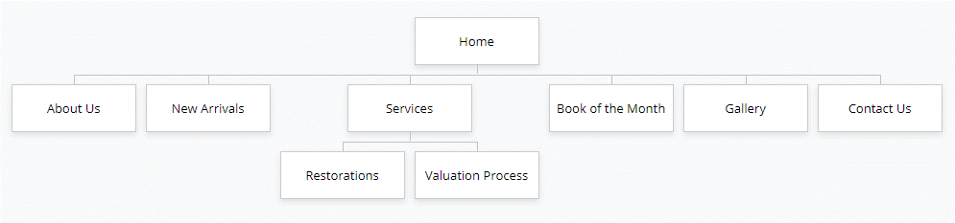

# Website Content

|  |  |
| --- | --- |
| **Page Name** | **Content** |
| Home | This will be the home page. It will have a photo of the store and some basic contact info like address, email and phone number. Next to the main content will show customer reviews and an announcements section. |
| About Us | This will give a brief history of the store and info about Julia and her staff. |
| New Arrivals | This will show books that are new to the store or are arriving soon, it will include info like what the book is and its history/ where it has been. |
| Restorations | This will show books that they have restored in the past, it will show before and after photos of the books. This might include a video showing a restoration process. |
| Valuation Process | This will show how they evaluate the books and how they determine the price. |
| Book of the month | This page will show a selected book of the month, it will show a photo of the book and info about it like the author a brief summary of the book and its condition and where its been. |
| Gallery | The gallery will have photos of books that have come and go or books that have been restored or even 1st edition and collectors’ books. |
| Contact Us | This page will include a form where users can submit queries about a book, they can request an evaluation or request a restoration. |

# User Interaction

The user will be able to use a form to submit queries on books, request a valuation of a book or request a restoration, there will also be a video about the restoration process on the restorations page. The form will be made using JavaScript and will have its own page, and the video will be found on the internet for the time being. There will also be links to Twitter and Instagram at the bottom of the page.

# Designs

## Company Logo

Here I have designed a logo for use on the website

Ye Olde Bookshop Logo


## Desktop View

Here is an overview of what the website will look like on a desktop, the content in the design are placeholders

Website design prototype for desktop viewers


## Mobile View

Here is an overview of what the website will look like on a mobile phone, the content in the design are placeholders

|  |  |
| --- | --- |
| Website Prototype for mobile viewers | Website Prototype for mobile viewers with the navigation extended |

# Search Engine Optimisation

To make this site easier to find, I will create unique and accurate page tittles. This let’s google and the user know what the topic of the page is. I will add a description tag to individual webpages, this gives google, other search engines and the user a short summary of the page. I will also make sure that the websites are saved in appropriate locations, so they are faster for google to find. The site will also be responsive so that it is usable for smaller screen users. Doing all of these things will increase website views as it makes it easier for google to search the page and display relevant content to the users.

# Domain Name

Domain names are the address where the website can be found, for example www.google.com.

For the domain name I recommend using (yeoldebookshop.com). Because your website will be worldwide, having the .com will give users all over the world access to your website, when a website has (.co.nz) on the end it usually means that when a user searches for your site it is location specific. Search engines use the (.com) and (.co.nz) to identify the audience the website is trying to reach. The domain name specified above, it would cost $9.99 per year for the first 2 years, then after that it goes to $32.99 per year. This domain name is offered by [GoDaddy](https://nz.godaddy.com/domainsearch/find?checkAvail=1&domainToCheck=ye+olde+bookshop)

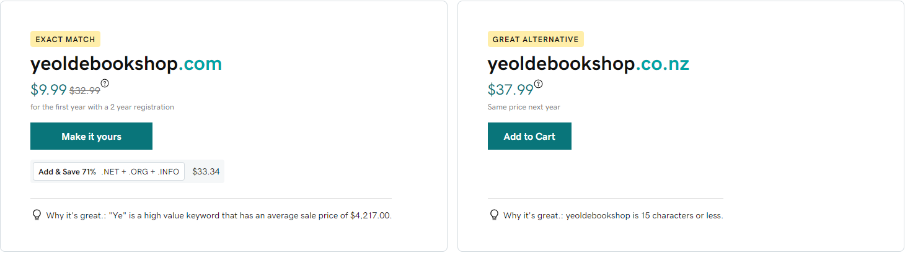

# Hosting

Website hosting is where you pay for website hosting services which will provide a space to store your website in a web server, these web servers allow the website to be always running and online. This allows for easier access and maintenance in the future.

|  |  |
| --- | --- |
|  | For hosting your website, I recommend using FreeParking.co.nz. They are based in New Zealand and offer a suitable hosting plan for your website. For $13.42 per month, you get everything you need to maintain the website. |

# Copyright

When it comes to copyright, before the website becomes live for the first time, the images and content will need to be your own. This means either taking your own photos and videos or acquiring the rights to use the photos and videos. To show that the content you own is copyrighted, there will be a copyright disclaimer with your bookshops name and current year at the bottom of the page. To get the rights to use someone else’s content you may need to ask them directly or acquire the right licencing.

# Budget

The cost to develop the website is shown in the invoice below. This covers the cost of designing and building the website, hosting and domain costs and the cost to design your company logo.

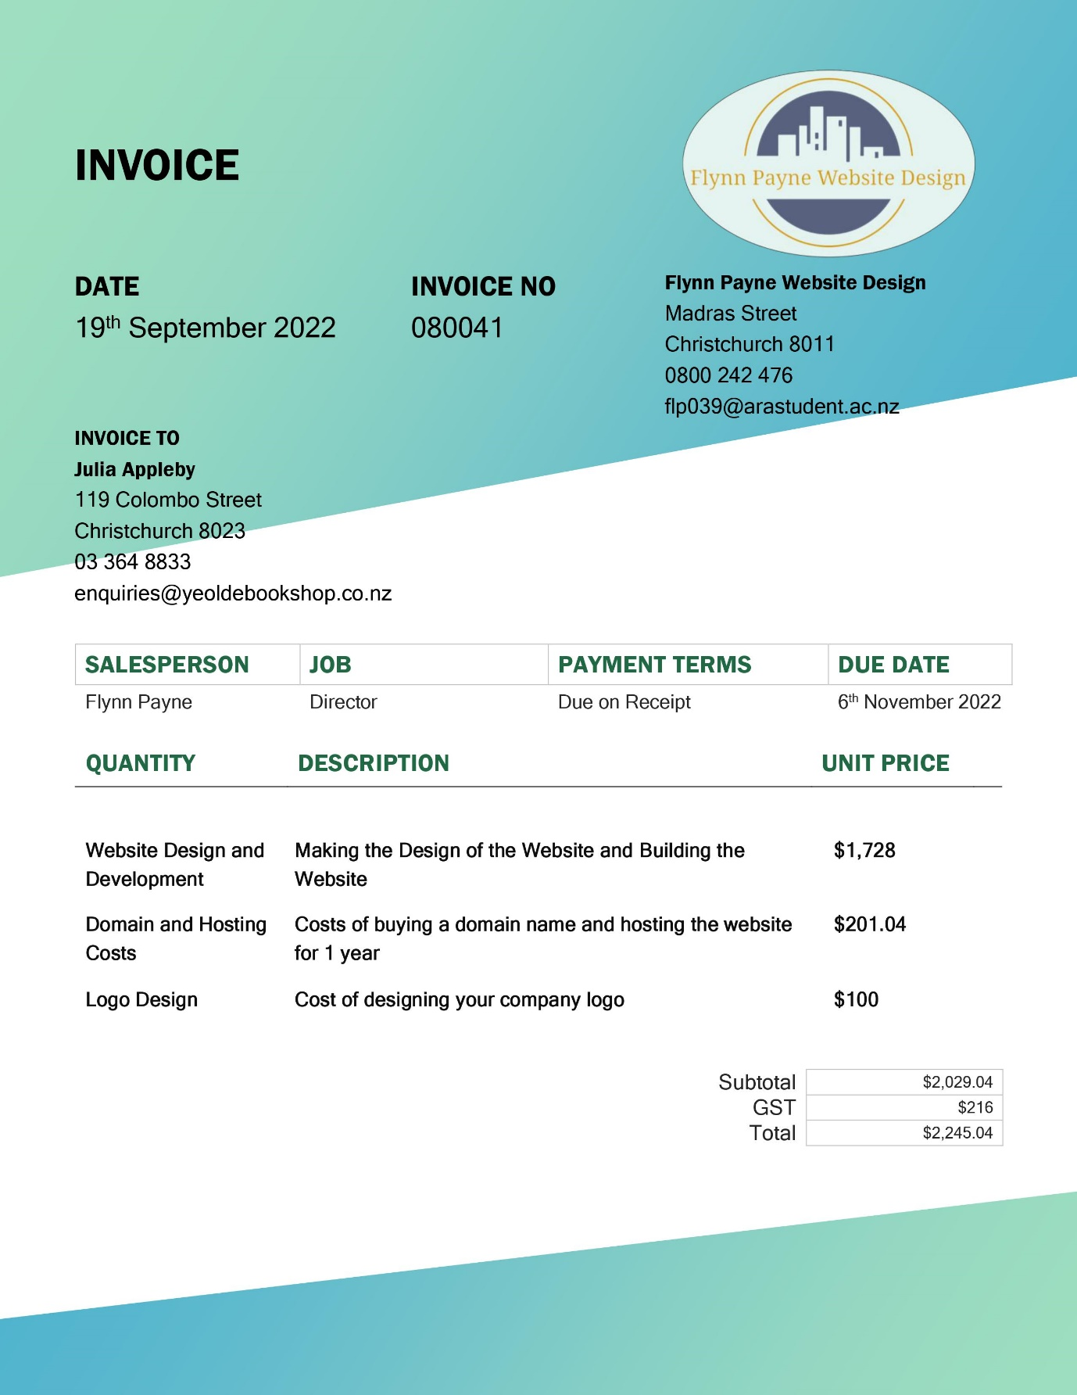

# Signoff for Client

___________________________ ___________________________

Clients Name Project Manager Name

___________________________ ___________________________

Date Date